
Name: Abdul Samad
Program: BSSE Group A
Semester: 5th
Date: October 20, 2026
*-----------------------------------------------*

Lab Task 8
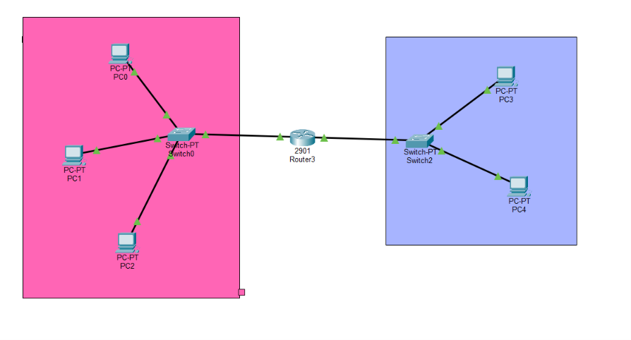
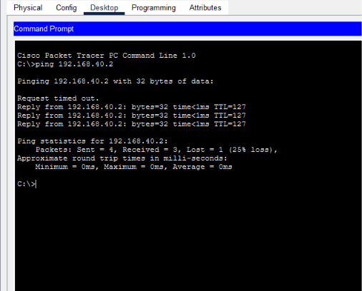

Physical:
Honestly, Mam, I tried so many times, but I failed to make it like in today’s class I was with my friend resolving some issues regarding his semester freezing so because of that I was unable to attend the lecture perfectly. At the end I was just like not knowing anything about physical network creation. I apologize for this and I will work to improve and learn it. I don’t want to copy from others. Hope you will understand my situation and consider my request at this time. Thanks
*-----------------------------------------------*

The End

